Title: Characterizing guitar pedal’s effects on a guitar signal output
Date: 6 November 2020
Name: M. Zirdi Syukur
Partner: None

Aim:
The aim of this experiment is the quantify and qualitatively observe the effects of a guitar pedal on an input signal. In particular, this lab looks at the time dependent effect of a delay pedal and the waveform distorting effect of a fuzz pedal.

Materials and apparatus:
1 Guitar
1 Audio interface
1 signal generator
1 Oscilloscope
1 Power supply (9V)
3 quarter inch to BNC cables
2 quarter inch to quart inch cables

Setup:
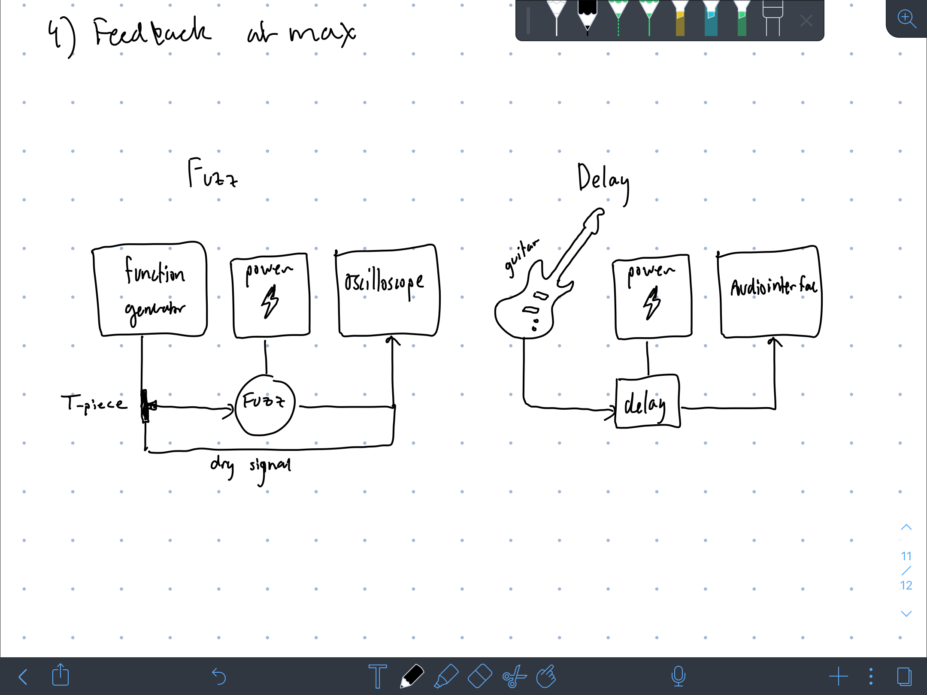

Procedure:
Measuring the Fuzz:
- First plug in the fuzz to the guitar and amplifier to understand the role of each knob in effective the tone of the guitar.
- Prep the fuzz apparatus according to the diagram above
- Input a sine signal into your pedal and into your oscilloscope using the function generator (use 100 mV). Use the frequencies 100, 500, 1000, and 2000 Hz.
- Record the waveform properties of the fuzz in the oscilloscope. In particular, compare the dry signal to the fuzz’d signal.
- Save the images of the oscilloscope
- Repeat this experiment’s measurements with a square wave wit a duty cycle of 10%
Measuring the Delay:
- First plug in the delay to the guitar and amplifier to understand the role of each knob in effective the tone of the guitar.
- Prep the delay apparatus according to the diagram above
- Generate an input signal with your guitar on all 6 strings
- Record the waveform properties of the delay in whatever program you use (I used audacity). Do this for varying position of the knobs on the delay
- Save the recorded audio on the audio interface for analysis for quantifying the delay pedal’s effect

Results and analysis:
Fuzz pedal:

Fuzz pedal has two knobs:
- Volume: controls output gain of the pedal
- Fuzz: controls how much of the “fuzz” effect is applied to the signal

Figure 1.
Fuzz at max, Sine waves
100, 500, 1000, 2000 (left to right top to bottom)
Adjusting the fuzz knob didn’t have much effect on the waveform for a sine wave. It however very slightly adjusted the phase of the wave. For example, at 100 Hz, the waveform when the fuzz is at 0 was 0.4 milli seconds out of phase with the waveform shown above.
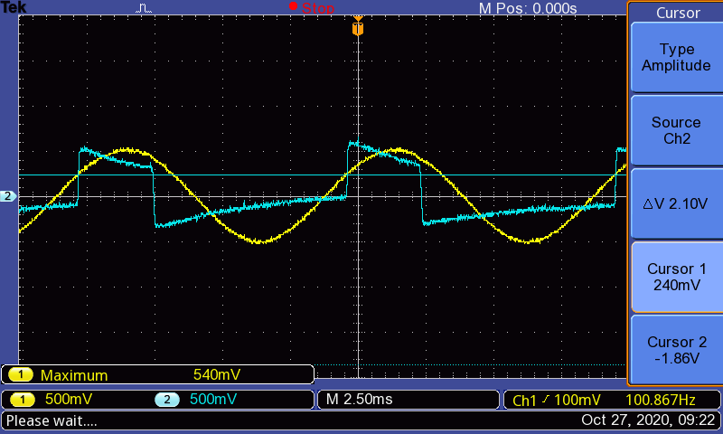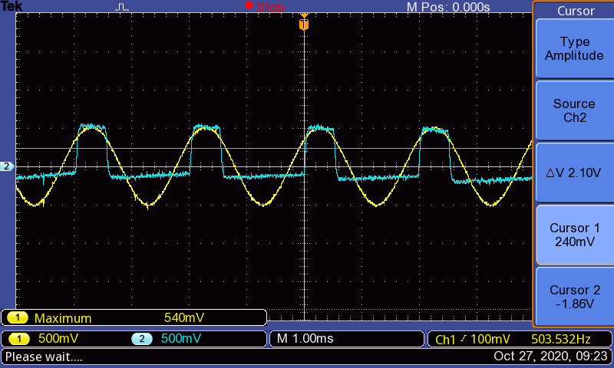
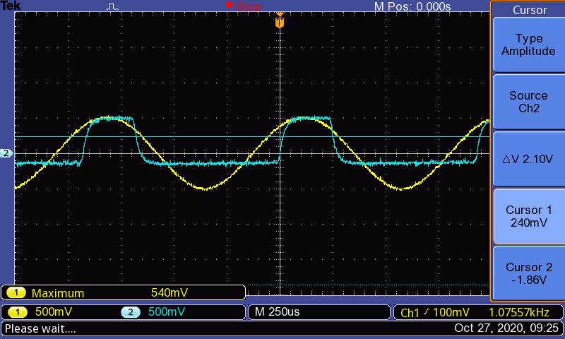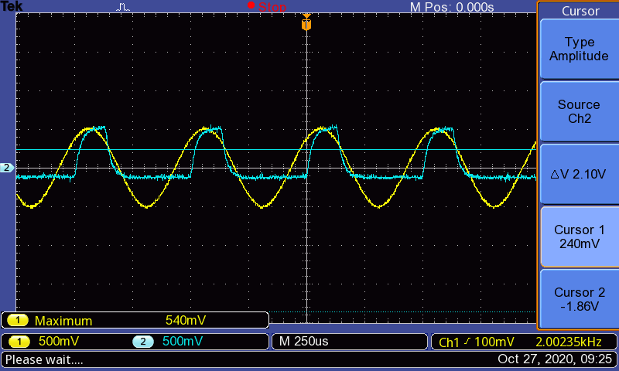

Figure 2.
Fuzz at max, Square waves
100, 500, 1000, 2000 (left to right top to bottom)
Adjusting the fuzz knob when a square wave was inputted did change the waveform. Higher fuzz settings resulted in waveforms that were more square-wave-like (according to the waveform shown below. When the fuzz was set to 0, the waveforms had more curves in particular on the top and bottom parts of the cycle. In other words, the higher fuzz settings clipped more of the waveform.
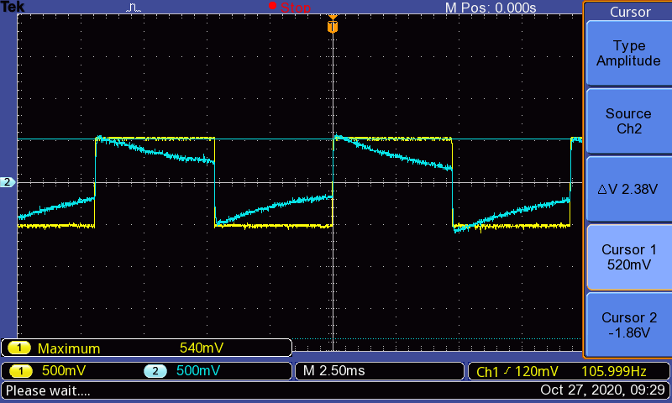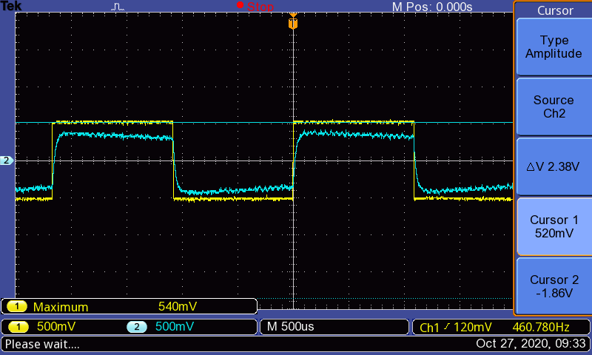
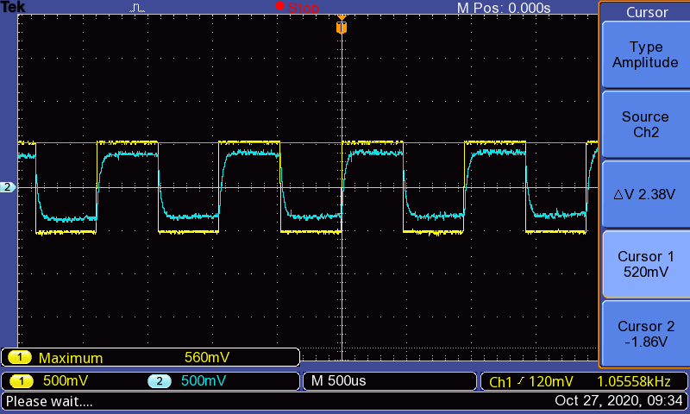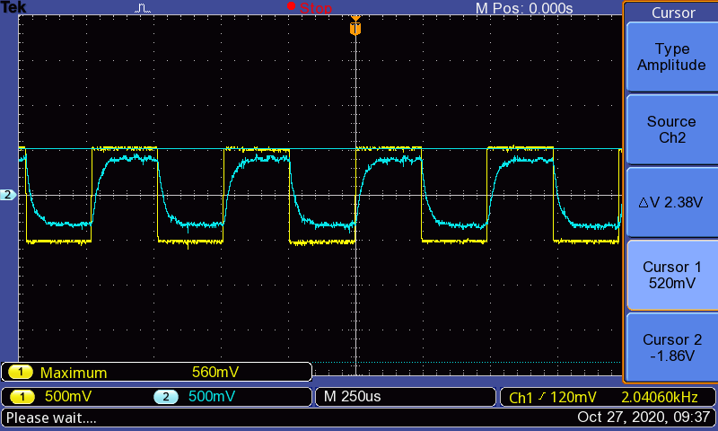

Delay pedal: repeats a signal to make an echo effect
Delay pedal has three knobs:
- Delay: controls rate of delay
- Feedback: controls how long the delay is present (maximum makes it infinitely repeating)
- Level: controls volume of the delay effect
Unfortunately, due to data corruption, the quantitative aspects of this pedal are missing. It is expected that the delay knob controls the distances between waveform peaks when the delay pedal repeats a signal. The feedback control is expected to control the decay in amplitude of the echo. If the feedback is maximum, the amplitude will never decrease and repeat forever. Anything less than that will slowly decrease the amplitude of the echo until it is effectively quiet. This essentially controls how long the delay effect lasts. The level Is just expected to adjust the volume of the waveform broadly.

Conclusion:
It is hard to quantify the effect of the fuzz face on the guitar signal because it does not solely affect some quantity like the phase or voltage. Instead it adjusts the clipping of the waveform (thus in turn does change a little bit about the other quantifiable measures).

It is clear the first experimental observations that increasing the fuzz knob on the pedal causes more clipping, or a more square-like wave. The sine wave is clearly more square-like after having gone through the fuzz face. And as the fuzz knob is decreased, this square-like wave becomes more rounded off like (less clipping).

This strangely isn’t necessarily the case with the square wave. I would expect the square wave, which is already square-shaped, to not change in shape after going through the fuzz face. Instead it becomes more slanted and curved in comparison to the raw wave. Yet nonetheless, decreasing the fuzz knob still rounds off the curves of the output signal implying that it still adjusts the clipping of the waveform, even though just turning it on makes it “less square-like”.

This is something I found strange in my lab. I would hypothesize that the signal that goes through the fuzz face would be essentially the same wave as that produced by the guitar when the fuzz face is off or if it has a 0 setting on the fuzz knob. This is because both situations would hopefully “true bypass” the signal and leave it unchanged. This is not what I found. When the fuzz knob was 0, or the fuzzface was off. The guitar sounded like it was unchanged (no effects), but the oscilloscope still showed the square like waves. I’m not sure if this was because of an error in the setup but if true, it may indicate that the pedal is not “true bypass” and distorts your signal significantly even when off

It is also observed that in both sine wave and square wave measurements, the fuzz face effects lower frequencies much more extremely. Lower frequencies are shown to have a more square-like shape after being fuzz’d while higher frequencies are clipped less. This agrees with qualitative observations as fuzz is often used for rough gritty power chords that are used for lower-frequency notes. Meanwhile the fuzz applies less on higher frequencies, where a guitarist would often do solo or melodic stuff that requires less gritty fuzz.

Overall it is clear that the fuzz has multiple and ranging effects on the waveform of a guitar, In particular, it’s emphasis on square-like waves indicate that the output signal is a much more complex superposition of waves that involve many more harmonics. This is likely reflected in the FFT analysis of the fuzz tone. This tone of course, is then found in many famous songs to create the musician’s gritty/rock tone.

